**1 click blue/green deployment using single autoscale group**

**Motive**- Our main motive is to reduce the manual intervention into the deployment.

**Approach**- 1 click blue/green deployment using an autoscale group that would be assigned to the new instance if created

**Diagram**-

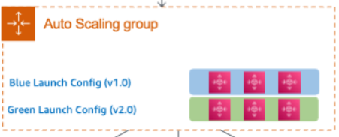

**Action-**

# AWS CodeDeploy offers two ways to perform blue/green deployments on EC2:

* In the first approach, AWS CodeDeploy makes a copy of an Auto Scaling group. It, in turn, provisions new Amazon EC2 instances, deploys the application to these new instances, and then redirects traffic to the newly deployed code.
* In the second approach, you use instance tags or an Auto Scaling group to select the instances that will be used for the green environment. AWS CodeDeploy then deploys the code to the tagged instances.

**Note- we will go with the second approach considering using only one autoscaling group.**

1. We will firstly create IAM role later security group for the EC2 instance.
2. Expecting the code would be pushed by the developer into aws code commit.
3. We will create a launch configuration, autoscaling group, target group, load balancers and configure servers.
4. Then will configure code build, configure the code build project and set the artifacts to S3 bucket to store build output.
5. Then we will configure code Deploy, select blue/green deployment and then select “automatically copy Amazon EC2 auto Scaling group” and set the auto scaling group to the one we created.
6. Then deploy the application under blue environment.
7. Now, we will configure the code pipeline, again configure the code deploy.
8. Now, we will validate the blue/green environment by changing the code in the aws code commit and check whether it is applied or not.

**We will now try to implement the steps and approach as mentioned above as soon as we are provisioned with the AWS account for Hands-on.**